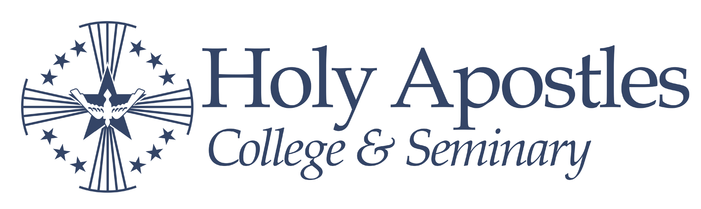
BA Philosophy 10-1-2025
Name:
Transfer Credits:
Entry Semester:
Undergraduate Degree Plan Checklist

Core Courses (former number) [prerequisite] | Semester | Major Courses and Electives | Semester
Theology |  | Required
PAS 161 Foundations of Theology I |  | PHH 301 History of Ancient Philosophy
PAS 162 Foundations of Theology II |  | PHH 304 History of Medieval Philosophy
SAS 201 (101) Sacred Scripture [PAS 161] |  | PHS 492 Philosophy of God
DTH 200 Dogmatic Theology [PAS 162] |  | Philosophy Elective:
MTH 300 Moral Theology [SAS 201, DTH 200] |  | Philosophy Elective:
Philosophy |  | Electives
PHS 121 Logic |  | Elective:
PHS 201 (421) Philosophy of Nature |  | Elective:
PHS 202 (490) Metaphysics |  | Elective:
PHS 450 Philosophy of Man |  | Elective:
PHE 450 Ethics |  | Elective:
English in the Humanities |  | Elective:
ENG 115 Writing and Composition |  | Elective:
HUM 125 Sacred Humanities |  | Elective:
ENG 102 (310) Rhetoric |  | Elective:
History in the Social Sciences |  | Elective:
HIS 101 Western Civilization I |  | Elective:
HIS 102 Western Civilization II |  | Elective:
SOC 275 Economics |  | Elective:
POL 253 Political Science |  | Elective:
Mathematical and Natural Sciences |  | Elective:
SCM 100 Our Physical World |  | Notes:
SCM 101 College Mathematics
SCM 171 Bio, SCM 220 Chem, or SCM 201 Phy
Basic Requirements:
● Undergraduate students must maintain a minimum cumulative GPA of 2.0.
● A minimum of 120 credits is required to graduate. A minimum of 30 credits is required to be completed in the student’s major. Of those credits, 9 should be in upper-level coursework (300-level or above).
● If a second major is pursued, some of the electives will be re-allocated to that major.
● 6 credits of language electives (GRK, LAT, HEB) are recommended.
Acceptance Notes:
(Date) Congratulations on your acceptance! You have earned () transfer credits toward your degree. If you take courses elsewhere, please speak with your academic advisor to verify they will transfer. All Theology and Philosophy courses must come from a Cardinal Newman Guide school. We wish you success in your future academic endeavors at Holy Apostles.
Advising Notes:

