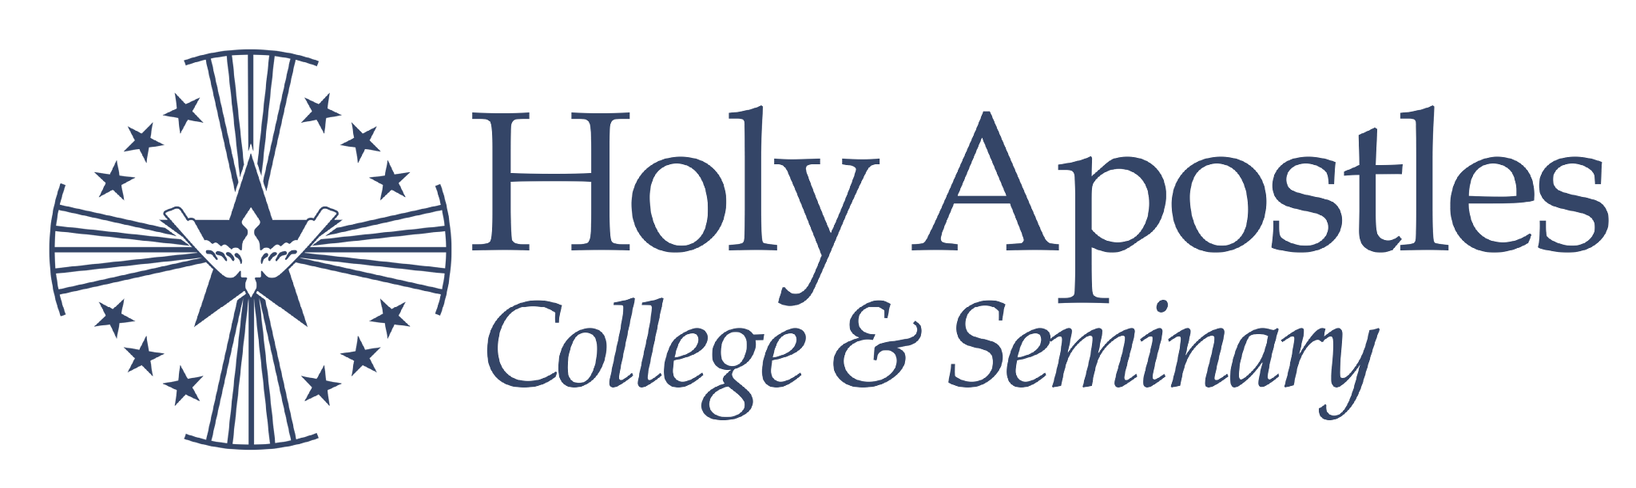
AA Theology 4-15-2026
Name:
Transfer Credits:
Entry Semester:
Undergraduate Degree Plan Checklist

Core Courses | Semester | Major Courses and Electives | Semester
Theology |  | Required
PAS 161 Foundations of Theology I |  | Theology Elective:
PAS 162 Foundations of Theology II |  | Theology Elective:
Philosophy |  | Electives
PHS 121 Logic |  | Elective:
PHS 201 (421) Philosophy of Nature |  | Elective:
English in the Humanities |  | Elective:
ENG 115 Writing and Composition |  | Elective:
HUM 125 Sacred Humanities |  | Elective:
History in the Social Sciences |  | Elective:
HIS 101 Western Civilization I |  | Elective:
HIS 102 Western Civilization II |  | Elective:
Mathematical and Natural Sciences |  | Notes:
SCM 100 Our Physical World
SCM 101 College Mathematics
Basic Requirements:
● Undergraduate students must maintain a minimum cumulative GPA of 2.0.
● A minimum of 60 credits is required to graduate.
● 6 credits of language electives (GRK, LAT, HEB) are recommended.
Acceptance Notes:
(Date) Congratulations on your acceptance! You have earned () transfer credits toward your degree. If you take courses elsewhere, please speak with your academic advisor to verify they will transfer. All Theology and Philosophy courses must come from a Cardinal Newman Guide school. We wish you success in your future academic endeavors at Holy Apostles.
Advising Notes:

